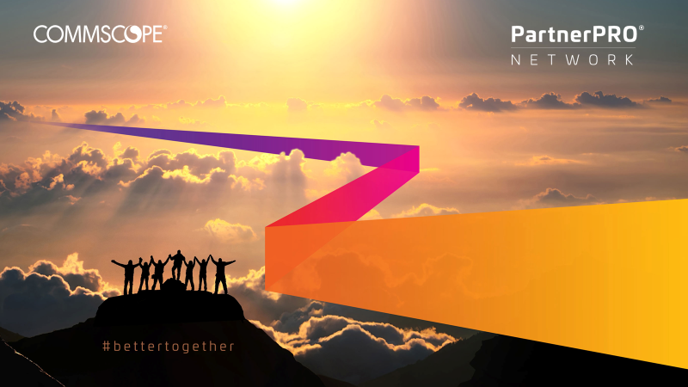

CommScope PartnerPRO 2020 Global Partner Conference

Get insights into CommScope’s sales, technology and go-to-market strategies, interact with cutting edge technology demos, and network with peers at this year’s conference. For the first time ever, we’re bringing Infrastructure Partners together with Ruckus Networking Partners to learn cross-selling strategies and see how we are truly #bettertogether.

Location and Dates
Orlando World Center Marriott Hotel
Orlando, Florida, USA
June 16-18, 2020

Exhibition, Demos and Breakouts

At this year’s event, catch some of our new solutions in action in our exhibition hall and in our breakout sessions.
Wi-Fi 6 | PoE | Hospitality
IoT | Network Analytics | K-12 Education
Multi-Tenant Data Centers | Commercial Real Estate | Higher Education
Self-Healing Networks | Cloud | Federal Government

Schedule an Executive Meeting

Please contact your Partner Account Manager to request a meeting with our executive leadership team. Spaces are limited

Translations Available

Mainstage general sessions will be available in both Spanish and Korean.

DAY 1: Tuesday, June 16th

9:00 AM – 12:30 PM | Registration | Pick up your conference badge and materials.
9:00 AM – 12:30 PM | Sponsor Expo | Visit the exhibits to learn about new solutions & opportunities that may benefit your business
12:00 PM – 1:00 PM | Welcome Lunch
1:00 PM – 1:30 PM | Conference Kick-Off and Sales Strategy  Stephen Kowal, SVP, WW Sales | Welcome to CommScope's Global Partner Conference. Stephen Kowal will kick off the event with sales strategy insights for 2020.
1:30 PM – 2:00 PM | PartnerPRO Network Introduction and Strategy  Raelyn Kritzer, VP, WW Channel | Raelyn Kritzer will give an overview of the PartnerPRO Network's strategy and vision to enable your business to drive revenue.
2:00 PM – 2:45 PM | Fireside Chat with Alexander Pease and Eddie Edwards  Eddie Edwards, CEO and President  Alexander Pease, CFO | Meet CommScope's CEO Eddie Edwards, joined by CFO, Alexander Pease in this fireside chat.
2:45 PM – 3:15 PM | CommScope Go-to-Market Plan  CommScope CCO | Hear from our marketing executives about how CommScope goes to market and how we drive demand for you.
3:15 PM – 3:45 PM | Break & Sponsor Expo
3:45 PM – 4:15 PM | The Future of 5G  Morgan Kurk, CTO | Morgan Kurk, CTO, will take the stage to discuss the future of 5G and how it will impact the industry.
4:15 PM – 5:15 PM | Looking Forward - Technology Futurist
5:15 – 5:30 PM | Day 1 Wrap-Up

DAY 2: Wednesday, June 17th

8:00 – 8:10 AM | Welcome to Day 2
8:10 – 8:40 AM | VCN  Ben Cardwell  SVP, Mobility and Connectivity Solutions | Ben Cardwell kicks off the day discussing Venue and Campus Networks.
8:40 – 9:10 AM | Building Smart Cities  Mourne Erasmus  Director, Smart Cities | Mourne Erasumus shares how CommScope solutions work together to build a smart city.
9:10 – 9:40 AM | Hear from Our Sponsor
9:45 – 10:15 AM | Break & Sponsor Expo
Breakouts
Build your own schedule. Click here to see workshop availability.
10:15 – 11:15 AM | Breakout #1
11:30 – 12:30 PM | Breakout #2
12:30 – 2:00 PM | Lunch & Sponsor Expo Open
2:00 – 3:00 PM | Breakout #3
3:15 – 4:15 PM | Breakout #4
4:15 – 5:30 | Sponsor Expo Open

DAY 3: Thursday, June 18th

8:00 – 8:05 AM | Welcome to Day 3
Solutions Introduction and Roadmaps
8:05 – 8:45 AM | Infrastructure  Ernie Pickens and John Schmidt | Hear from Ernie Pickens and John Schmidt who will deliver the Infrastructure product roadmap and solutions overview.
8:45 – 9:15 AM | DCCS / DAS  Darla Braun | Darla Braun will provide an overview of the DCCS and DAS product line and share roadmap information for future products.
9:15 – 9:40 AM | Networking  Siva Valliappan and Bart Giordano | Siva Valliappan and Bart Giordano will take the stage to share the Ruckus product roadmap and an overview of current solutions.
9:40 – 10:10 AM | Hear from Our Sponsor
10:10 – 10:40 | Break & Sponsor Expo
10:40 – 11:15 AM | Executive Q&A Panel | Want to get your questions answered by our Executive team? Hear from Stephen Kowal, Eddie Edwards, Morgan Kurk, Raelyn Kritzer, Pramod Badjate, and Ben Cardwell on our executive Q&A panel.
11:35 – 12:35 PM | Breakout #5
12:35 – 2:00 PM | Lunch & Sponsor Expo
2:00 – 3:00 PM | Breakout #6
3:15 – 4:15 PM | Breakout #7
4:15 – 5:30 PM | Sponsor Expo Open

Breakout Availability
Availability | Title | Description
Breakout 1-7 | Industry: How to Sell Cloud | The forecast for this breakout is Cloudy with a chance of $$$. Learn how to sell Cloud effectively.
Breakout 1-7 | Industry: Higher Education | Learn how to address specific needs for Higher/Secondary Education vertical with cutting edge technologies.
Breakout 1-7 | Industry: Hospitality | Learn how to sell key technologies for the Hospitality industry, including Wireless, DAS, and CBRS, along with Fiber-to-the Room solutions.
Breakout 1-7 | Industry: K-12 Education | Meet the education team to learn key technologies and strategic alliances that are driving growth for K-12 Education.
Breakout 1-7 | Industry: CRE & MDU | Selling into Commercial Real Estate: MDU and more
Breakout 1-7 | Industry: Multi-Tenant Data Center | Grow the value and capabilities of your MTDC offering and gain a competitive edge.
Breakout 1-7 | Technology: IoT | Learn how to solve unique challenges across key verticals with IoT.
Breakout 1-7 | Technology: PoE | Selling performance with Power over Ethernet for connected devices
Breakout 1-7 | Technology: Self-Healing Networks | Join us to hear how our networks can address critical issues before they happen.
Breakout 1-7 | Technology: Wi-Fi 6 | Hear about the opportunity with Wi-Fi 6 and how it will change the next generation of connectivity.
Breakout 1 and 5 | Workshop: Selling into the Federal Government | Learn how to win with CommScope in the U.S. federal government.

This agenda is for informational purposes only and is subject to change.

